**QATAR UNIVERSITY**

College of Engineering

Dept. of Computer Science & Eng.

Spring 2023 Semester

**CMPS 350 – Web development Fundamentals**

**Project - Phase 1**

**CRN:** 23613**, Section:** L02

Submitted: April 30th, 2023

**Professor Mahmoud Barhamgi**

|  |  |
| --- | --- |
| Student Name | QUID |
| Mohamed Dhia Abdaoui | 202005886 |
| Ridhwan Athaullah | 202005171 |
| Mohamad Allaham | 202005872 |

Table of Contents

1. Current status of the project implementation 2

2. Team member contributions 2

3. Visual overview of the project 4

4. Project Source Code 9

# 1. Current status of the project implementation

As the project neared completion, we were proud to announce that we had achieved 95% of what was needed to be implemented. However, the team acknowledged that difficulties along the way.

Specifically, the team struggled with the "update schedule" use case, which posed some unique challenges. While we were able to update existing schedules successfully, we faced challenges when attempting to add more sessions to existing schedules. Despite out best efforts, we were unable to resolve this issue before the project's deadline.

Furthermore, the team also faced challenges related to the location dropdown list during updates. On occasion, the location dropdown list failed to load properly, which could cause issues for users attempting to update the schedule. This was a frustrating challenge for the team, as we understood the importance of ensuring that the platform was user-friendly and easy to navigate.

# 2. Team member contributions

|  |  |  |  |
| --- | --- | --- | --- |
| Student Name | QUID | accomplished tasks | Overall contribution |
| Mohamed Dhia Abdaoui | 202005886 | Usecase 1,2 | 33.3% |
| Ridhwan Athaullah | 202005171 | Usecase 4, 5 | 33.3% |
| Mohamad Allaham | 202005872 | Usecase 3, 4 | 33.3% |

The team collaborated by dividing the project into specific use cases and assigning each member a set of responsibilities. Mohamad Dhia focused on use cases 1 and 2, which involved user login and paper submission. Mohamad Allaham took charge of use cases 3 and 4, which involved paper review and scheduling updates (ADD/UPDATE/DELETE). Meanwhile, Ridhwan contributed to use cases 4 and 5, which involved scheduling object management (ADD/UPDATE/DELETE) and (DATE FILTER). The team maintained regular communication to ensure seamless integration of their work towards achieving the project's overall objectives. As the project neared completion, the team combined each use case to function in accordingly.

During the course of the project, the team encountered a significant challenge that hindered the progress of their work. Specifically, we found it challenging to modify or manipulate JSON files using vanilla JavaScript. This obstacle made it difficult for the team to carry out critical functions related to the project's objectives.

As we attempted to find a solution, the team discovered that local storage could serve as an alternative to manipulating JSON files. While this provided a temporary solution, it wasn't the most efficient way to handle the project's needs. The use of local storage presented its own set of challenges, including slower load times, limited storage capacity, and the need to ensure that data remained consistent across different browsers.

Despite the challenges, the team persevered and found ways to work around the limitations of local storage. They adopted various strategies to optimize performance and improve efficiency, such as minimizing the amount of data stored in local storage, improving data compression techniques, and optimizing data retrieval processes.

# 3. Visual overview of the project

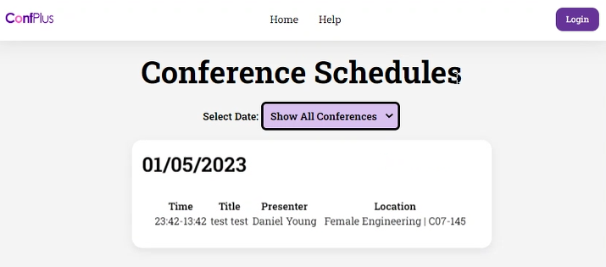

Figure 1 Main HomePage

Figure 2 Login Page

**After Successful Login:**

**If Username is pressed:**

**Homepage view:**

**(for organizer):**

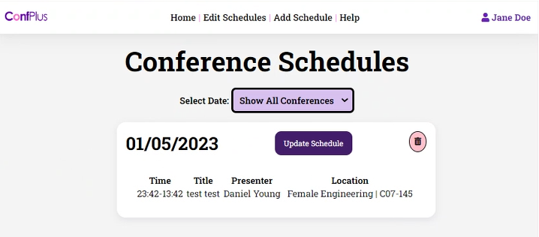

**Create Scheduleform:**

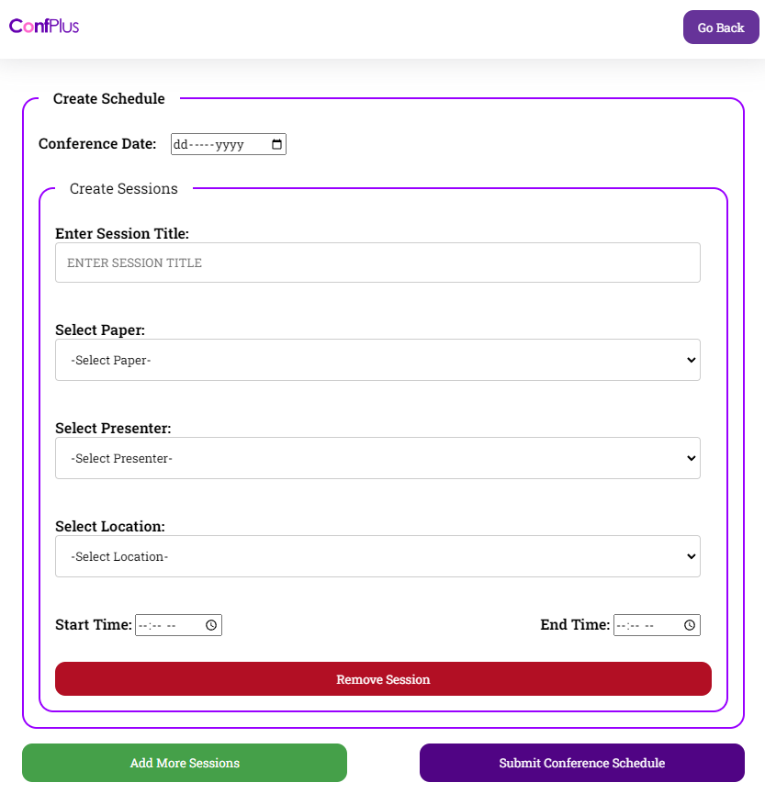

**Modify Schedule:**

**(for Authors):**

**Submit paper:**

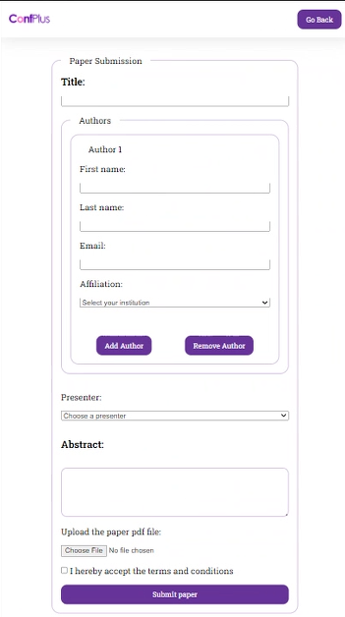

**(for Reviewer):**

**Submit review: (reviews paper they are assigned to)**

Date filter:

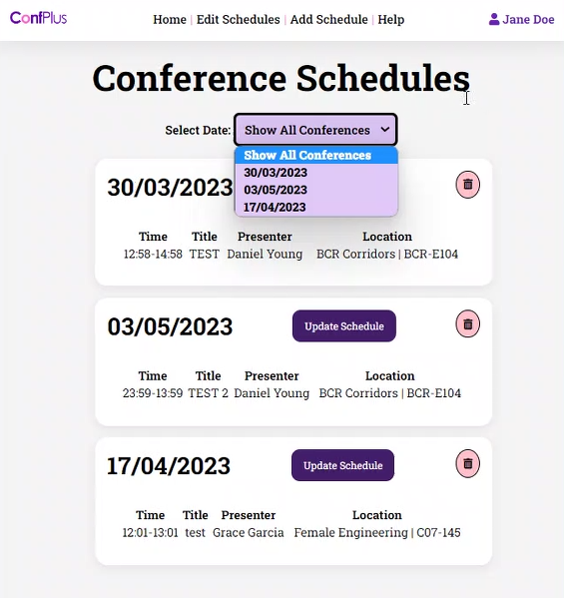

# 4. Project Source Code

Project link from GitHub: <https://github.com/ridhwan-ra2005171/WebDevPhase1>